Resazomycins: A Family of Novel Antibiotics to Target
Clinically Significant Gram-Negative Bacteria
Kendall Souder

Abstract
The discovery and application of novel antimicrobials is essential to combat the increasing development of antibiotic resistant bacteria. Many strains of clinically significant gram-negative bacteria such as Francisella tularensis, the causative agent of tularemia, and Neisseria gonorrhoeae, the causative agent of sexually transmitted gonorrhea, have developed resistance to commonly prescribed antibiotic medications. Resazurin (Rz) is a commonly used, blue-colored, cell viability dye that is reduced to a fluorescent pink compound called resorufin in metabolically active cells. Resazurin and its analogues have demonstrated novel antimicrobial effects in select strains of multi-drug resistant F. tularensis and N. gonorrhoeae, in vitro and in vivo. Exploring resazurin derivatives as antibiotics to treat tularemia and gonorrhea will limit the development of resistant microbes due to the drug’s specific strain scope and unique target system. The mechanism of Rz bactericide is still vastly unknown, and future studies should investigate the role of lipoproteins and distribution of membrane proteins in F. tularensis and N. gonorrhoeae cellular susceptibility to resazomycins.

Introduction
The CDC estimates that there are nearly 3 million new cases of antibiotic-resistant infections annually, resulting in 35,000 deaths and billions of dollars in health care costs each year (Biggest Threats and Data | Antibiotic/Antimicrobial Resistance | CDC, n.d.). Development of new antibiotics has significantly slowed in the past few decades due to decreased production profitability, while overall antibiotic resistance has continued to rise (Biggest Threats and Data | Antibiotic/Antimicrobial Resistance | CDC, n.d.). The development of new therapeutics is imperative to combat this crisis and prevent the loss of additional lives from once “curable” diseases.
Resazomycin drugs are derivatives of the compound resazurin. Resazurin is a natural chemical produced from a derivative of dihydroxybenzene that is obtained by the distillation of Brazilwood extract (Schmitt et al., 2013). Resazurin (Rz) is the active component of alamarBlue®, a commonly used, blue-colored, cell viability dye, that is reduced to a fluorescent pink compound called resorufin in metabolically active cells. (Figure 1) (Schmitt et al., 2013). Resazurin demonstrates significant antimicrobial effects against several clinically significant gram-negative bacterial strains, including F. tularensis, N. gonorrhoeae, N. polysaccharea, and N. sicca (Table 1) (Schmitt et al., 2013). When subjected to the recommended concentration (44 µM) of Rz, these four strains did not grow up in nutrient culture (Schmitt et al., 2013). This observed antibiotic activity led to the investigation of Rz as a natural treatment to combat the pathogenesis of specific gram-negative bacteria.
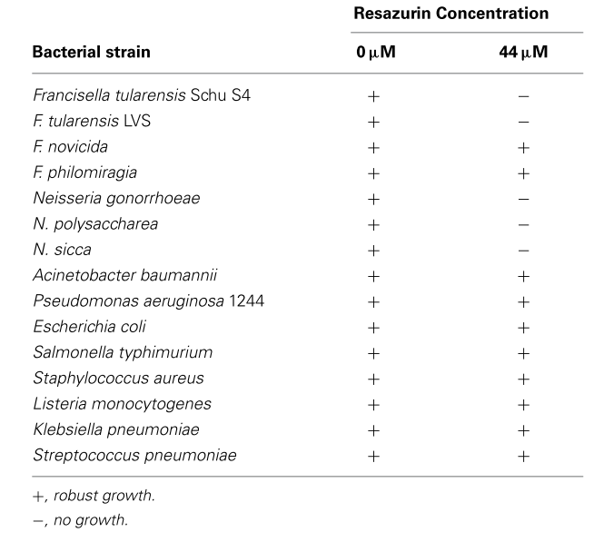
Table 1: Visually distinct bactericide was observed in F. tularensis LVS, N. gonorrhoeae, N. polysaccharea, and N. sicca strains cultured in the presence of 44 µM Rz (Schmitt et al., 2013).
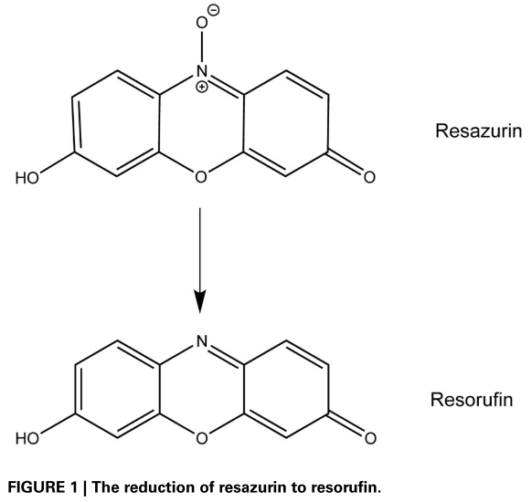
Figure 1: The reduction of blue resazurin (Rz) to a fluorescing pink resorufin compound seen metabolically active cells (Schmitt et al., 2013).
Resazurin
Resorufin

Bactericidal Action of Rz Against Francisella. tularensis
Franceisella tularensis is a gram-negative coccobacillus with four distinct subspecies found in the Northern hemisphere—novicida, mediasiatica, holarctica, and tularensis (McLendon et al., 2006; Oyston, 2008). F. tularensis is the causative agent of tularemia, a zoonotic infection passed among vertebrates and acquired by contact with, or ingestion of, contaminated material or inhalation of infectious microbes (Carlson et al., 2007; Chong et al., 2013; Horzempa et al., 2008; McLendon et al., 2006; Oyston, 2008). Inhalation of fewer than 10 cells can result in an acute pneumonia that is lethal in 30–60% of individuals if left untreated (Horzempa et al., 2008; Oyston, 2008). In addition, live vaccine strain (LVS) F. tularensis, the attenuated pathogen commonly investigated in the laboratory, does not elicit complete protection against virulent Francisella strains (Schmitt et al., 2012). The Centers for Disease Control and Prevention has categorized F. tularensis as a Category A bioterrorism agent due to the bacteria’s ease of aerosolization, low infectious dose, and high mortality rate (Carlson et al., 2007; Horzempa et al., 2008; Oyston, 2008). Given the lethality of infection and increasing resistance of F. tularensis, novel antimicrobials must be produced to combat this lethal bacterium.
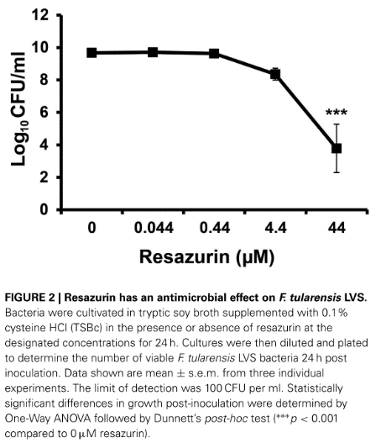
After initial data indicated resazurin possesses some antibiotic properties against F. tularensis species, Schmitt et al. (2013) cultivated LVS F. tularensis bacteria in tryptic soy broth supplemented with 0.1% cysteine in the presence of various concentrations of Rz for 24 hours. Cultures were then diluted and plated to determine the number of viable cells at 24 hours post inoculation. A Rz concentration of 4.4 µM resulted in a 10-fold reduction in viable F. tularensis compared to growth medium alone (Figure 2)(Schmitt et al., 2013). In addition, minute concentrations of both resazurin and resorufin compounds led to a 100-fold decrease the number of viable F. tularensis bacteria in broth culture after 24 hours of cultivation (Schmitt et al., 2013).
Figure 2: F. tularensis bacteria were cultivated in tryptic soy broth supplemented with 0.1% cysteine in the presence of resazurin at the designated concentrations for 24 hours. Cultures were then diluted and plated to determine the number of viable cells 24 hours post inoculation. (*** p < 0.001 compared to 0µM Rz) (Schmitt et al, 2013).

Bactericidal Action of Rz Against Neisseria gonorroheae
Neisseria gonorroheae is the causative agent of gonorrhea, the second most infectious sexually transmitted disease with 80 million new cases reported annually (Biggest Threats and Data | Antibiotic/Antimicrobial Resistance | CDC, n.d.). N. gonorrhoeae has developed resistance to almost all clinically-applied antibiotics, including sulfonamides, penicillin, and aminoglycosides, and as of 2007, only one class of antibiotics was still successful in treating gonorrhea (Schmitt et al., 2016). In 2013, it was projected that the spread of drug-resistant N. gonorrhoeae would cause 75,000 additional cases of pelvic inflammatory disease and 15,000 cases of epididymitis in the United States over the next 10 years (Biggest Threats and Data | Antibiotic/Antimicrobial Resistance | CDC, n.d.). The widespread antibiotic resistance in N. gonorrhea contributes to growing concern that gonorrhea will morph into an untreatable disease in coming years.
In a study by Schmitt et al. (2016), the minimal inhibitory concentration (MIC) of resazurin for N. gonorrhoeae, was determined to be 5.5 µg/mL, nearly eight times lower than the recommended concentration for viability determination. In addition, multi-drug resistant N. gonorrhoeae growth was completely inhibited in the presence of only 11 µg/mL Rz (Schmitt et al., 2016). Due to the observed antibiotic activity in vitro, an Rz treatment in vivo was applied to a murine model. Resazurin did not significantly decrease the bacterial growth in vaginally infected mice (Schmitt et al., 2016). The bactericidal effects of the Rz compound were compromised in vivo after binding to serum albumin, a common component of vertebrate blood. When an Rz derivative (resorufin pentyl ether) was applied to the murine model, a significant decrease in N. gonorrhoeae colonization was observed (Figure 3) (Schmitt et al., 2016).

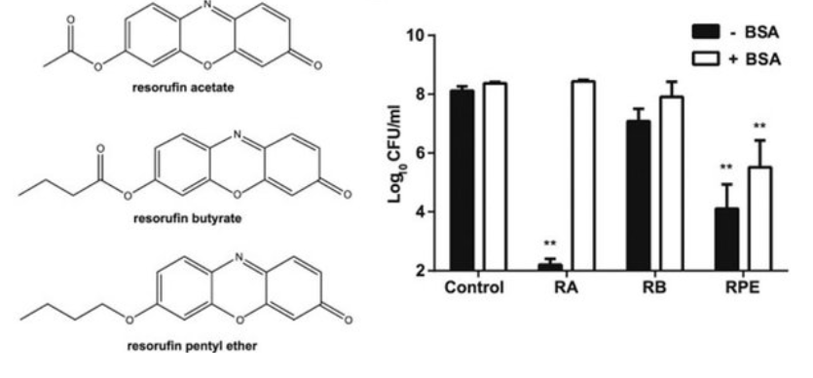
Figure 3: Resazurin analogues -- resorufin acetate (RA), resorufin butyrate (RB), and resorufin pentyl ether (RPE) -- were tested for antibiotic functionality against N. gonorrhoeae in the presence and absence of serum albumin. RPE was found to retain antibiotic properties in the presence of serum albumin and was applied to the murine model. RPE treatment significantly decreased vaginal N. gonorrhoeae colonization in infected mice (Schmitt et al., 2016).
Resazurin is widely used as a cell viability dye, but as an antibiotic it targets a specific range of medically significant gram-negative bacteria including F. tularensis and N. gonorrhoeae, as well as other taxonomically related microbes. The drug’s limited scope decreases the range of antibiotic resistance development when compared to widely dispersed, general action medications, such as sulfonamides, penicillin, and aminoglycosides. Further study into the mechanism of bactericide is required to develop Rz as a potential clinical treatment for tularemia or gonorrhea.

Mechanism of Action of Rz Bactericide
A common feature of the resazomycin-sensitive bacteria is the possession of a unique lipoprotein sorting system, LolDF (Figure 4). This system retains the same function, yet structurally, varies distinctly from the LolCDE sorting complex found in most gram-negative bacteria, including Escherichia coli and Pseudomonas aeruginosa, that are readily resistant to resazomycins (Chahales & Thanassi, 2015; LoVullo et al., 2015; Schmitt et al., 2013).
Lipoproteins are a diverse class of membrane associated proteins (Chahales & Thanassi, 2015; LoVullo et al., 2015). Genes that encode lipoproteins are highly conserved because these proteins are essential to cell survival (LoVullo et al., 2015). Lipoproteins constitute a majority of gram-negative cell envelopes, function in maintaining cell envelope stability, and facilitate pathogenic cell interactions (Chahales & Thanassi, 2015; LoVullo et al., 2015). In pathogenic microbes such as F. tularensis, lipoprotein encoding gene expression is upregulated at mammalian body temperature (37°C) in order to promote virulence (Horzempa et al., 2008). Pyridineimidazoles are a family of compounds that target lipoprotein sorting systems, but these compounds have only demonstrated effective inhibition in gram negative bacteria that possess the standard LolCDE system (McLeod et al., 2015).
The primary difference in the LolCDE and the LolDF complex is the acceptable acetylation of sorted proteins. Within the LolDF sorting system, Lnt, an N-acyl transferase that adds a third acyl group to the immature sorted peptide, was found to be nonessential (Figure 4) (LoVullo et al., 2015). This indicates that bacteria with this type of processing system would be able to export diacylated proteins in addition to triacylated proteins, and may indicate that LolDF possessing bacteria like F. tularensis and N. gonorrhoeae regulate lipoprotein acylation as a means to alter host responses during pathogenesis (Chahales & Thanassi, 2015; LoVullo et al., 2015).
In addition, this variant lipoprotein system may prove to be a target for resazomycin action. While many common antibiotics attack microbial cell membranes, DNA replication, or protein synthesis, resazomycins seem to target and alter the LolDF lipoprotein sorting system. The unique action of Rz to target and deactivate a unique cellular system would further champion it over other antimicrobials by reducing the ease of bacterial resistance evolution.
An initial study by Selmon-Miller, Whaby, and Schmitt (2019) sought to identify if the LolDF protein complex was a target of resazomycin action. The genes that encode the E. coli LolCDE transporter were cloned into an F. tularensis plasmid and then electroporated into LVS F. tularensis to see if the LolCDE protein complex would render the bacterium resistant to resazomycins. LolCDE-expressing LVS exhibited no significant difference in resistance to resazomycins compared to wild-type LVS (Whaby & Schmitt, 2019).
Bacteria possessing the LolDF sorting system correlate profoundly with resazurin susceptibility, however, the results of the initial Selmon-Miller, Whaby, and Schmitt (2019) study indicate that the non-essential Lnt variation may not play a role in the antibiotic action of Rz. Therefore, other universal members of the lipoprotein processing pathway common to all gram-negative Lol systems, such as Lgt and Lsp, may have unique functions in F. tularensis that have yet to be understood and could serve as the lipoprotein target of Rz.
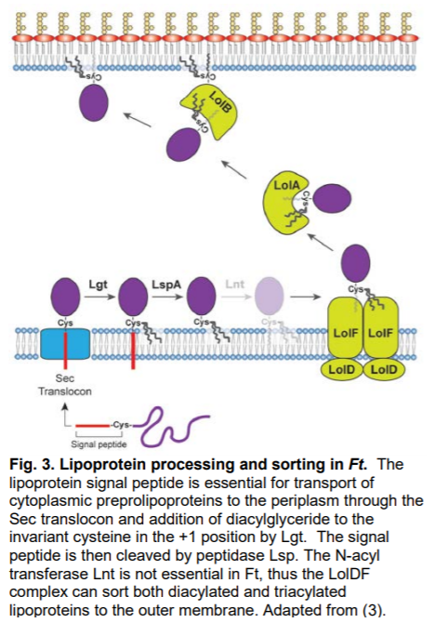
Figure 4: A schematic of the gram negative lipoprotein sorting pathway. The lipoprotein signal peptide is essential for passage through the Sec translocon into the periplasm. Lgt adds a diacylglyceride to the invariant cysteine located in the +1 position and then LspA cleaves the signal protein. Lnt, an N-acyl transferase, is non-essential in F. tularensis and N. gonorrhoeae lipoprotein sorting systems, allowing it to process both diacylated and triacylated peptides to the outer membrane (Chahales & Thanassi, 2015).

Current Investigation of Resazurin Antimicrobial Action and F. tularensis Cell Response
In order to gain a more complete understanding of the mode of action of resazomycins to disrupt the lipoprotein system of certain, clinically significant, gram negative bacteria, further study should be conducted on the genomics and proteomics of susceptible and resistant target cells. Genes of particular interest should be those that encode membrane proteins and proteins that comprise the lipoprotein sorting complex in order to determine how resazurin penetrates the cell and disrupts intracellular pathways.

In a 2020 study by Schmitt et al. (manuscript in preparation) genomic DNA was isolated from 48 resazurin-resistant LVS F. tularensis mutants and sent to Marshall University Genomics and Bioinformatics Core for sequencing. Nonsynonymous mutations were identified in ten different protein-coding F. tularensis genes, and approximately 50% of the isolates possessed mutations in FTL_1306 (dipA) and FTL_0959 (pilD) genes (Schmitt et al., 2020, manuscript in preparation). The rate of gene mutation in resistant cells suggests that PilD and DipA proteins may play a role in F. tularensis susceptibility to resazomycins.
DipA is a 353 amino acid protein predicted to possess a 20 amino acid Sec-dependent signal peptide, four Sel1-like repeat domains, and a C-terminal coiled-coil domain (Figure 5) (Chong et al., 2013). DipA is primarily localized to outer membrane has been shown to form a surface complex with other outer membrane proteins to facilitate virulent interactions with host cells (Chong et al., 2013). If resazurin attacks the LolDF lipoprotein sorting system and alters DipA association to the outer membrane, cell envelope instability may account for the observed decrease in F. tularensis viability. To clinically utilize resazomycins as a novel treatment for tularemia and gonorrhea, further investigation is necessary to elucidate the mechanism of action resazurin bactericide against F. tularensis and N. gonorroheae.

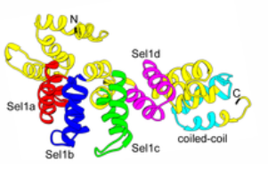
Figure 5. Schmeatic representation and three-dimensional ribbon structure of the 353 amino acid DipA protein with highlighted Sec-dependent signal peptide, four Sel1-like repeat domains, and a C-terminal coiled-coil domain. DipA is localized to the outermembrane via lipoprotein sorting and complexes with other protein to facilitate pathogenesis (Chong et al., 2013).
Work Cited
Biggest Threats and Data | Antibiotic/Antimicrobial Resistance | CDC. (n.d.). Retrieved October 9, 2020, from https://www.cdc.gov/drugresistance/biggest-threats.html
Carlson, P. E., Carroll, J. A., O’Dee, D. M., & Nau, G. J. (2007). Modulation of virulence factors in Francisella tularensis determines human macrophage responses. Microbial Pathogenesis, 42(5–6), 204–214. https://doi.org/10.1016/j.micpath.2007.02.001
Chahales, P., & Thanassi, D. G. (2015). A more flexible lipoprotein sorting pathway. Journal of Bacteriology, 197(10), 1702–1704. https://doi.org/10.1128/JB.00051-15
Chong, A., Child, R., Wehrly, T. D., Rockx-Brouwer, D., Qin, A., Mann, B. J., & Celli, J. (2013). Structure-Function Analysis of DipA, a Francisella tularensis Virulence Factor Required for Intracellular Replication. PLoS ONE, 8(6), e67965. https://doi.org/10.1371/journal.pone.0067965
Horzempa, J., Carlson, P. E., O’dee, D. M., Shanks, R. M., & Nau, G. J. (2008). Global transcriptional response to mammalian temperature provides new insight into Francisella tularensis pathogenesis. https://doi.org/10.1186/1471-2180-8-172
LoVullo, E. D., Wright, L. F., Isabella, V., Huntley, J. F., & Pavelka, M. S. (2015). Revisiting the gram-negative lipoprotein paradigm. Journal of Bacteriology, 197(10), 1705–1715. https://doi.org/10.1128/JB.02414-14
McLendon, M. K., Apicella, M. A., & Allen, L. A. H. (2006). Francisella tularensis: Taxonomy, genetics, and immunopathogenesis of a potential agent of biowarfare. In Annual Review of Microbiology (Vol. 60, pp. 167–185). NIH Public Access. https://doi.org/10.1146/annurev.micro.60.080805.142126
McLeod, S. M., Fleming, P. R., MacCormack, K., McLaughlin, R. E., Whiteaker, J. D., Narita, S. ichiro, Mori, M., Tokuda, H., & Miller, A. A. (2015). Small-molecule inhibitors of gram-negative lipoprotein trafficking discovered by phenotypic screening. Journal of Bacteriology, 197(6), 1075–1082. https://doi.org/10.1128/JB.02352-14
Oyston, P. C. F. (2008). Francisella tularensis: Unravelling the secrets of an intracellular pathogen. In Journal of Medical Microbiology (Vol. 57, Issue 8, pp. 921–930). Microbiology Society. https://doi.org/10.1099/jmm.0.2008/000653-0
Schmitt, D. M., Connolly, K. L., Jerse, A. E., Detrick, M. S., & Horzempa, J. (2016). Antibacterial activity of resazurin-based compounds against Neisseria gonorrhoeae in vitro and in vivo. International Journal of Antimicrobial Agents, 48(4), 367–372. https://doi.org/10.1016/j.ijantimicag.2016.06.009
Schmitt, D. M., O’Dee, D. M., Cowan, B. N., Birch, J. W. M., Mazzella, L. K., Nau, G. J., & Horzempa, J. (2013). The use of resazurin as a novel antimicrobial agent against Francisella tularensis. Frontiers in Cellular and Infection Microbiology, 3(DEC). https://doi.org/10.3389/fcimb.2013.00093
Schmitt, D. M., O’Dee, D. M., Horzempa, J., Carlson, P. E., Russo, B. C., Bales, J. M., Brown, M. J., & Nau, G. J. (2012). A Francisella tularensis live vaccine strain that improves stimulation of antigen-presenting cells does not enhance vaccine efficacy. PLoS ONE, 7(2). https://doi.org/10.1371/journal.pone.0031172
Whaby, M., & Schmitt, D. M. (2019). ISAIAH SELMON-MILLER. In Proceedings of the West Virginia Academy of Science (Vol. 91, Issue 1). https://pwvas.org/index.php/pwvas/article/view/491

